Peers Education

In our school club “Secrets of our planet”, which is implemented in the project Development of the natural science and reading competences, were our students focussed on topic Green Energy.
They created models of the three types of Power stations: wind, water and nuclear. They followed different schemes and videos which helped them to create specific details. They also prepared survey for the other students: Saving energies” to observe behaviour of the family members during Christmas holidays. They evaluated their research and published their results in the graphs and diagrams. They also prepared PowerPoint presentation for younger students for Peers Education. They explained them that saving energy is simple, what acts are logical and subconscious and done properly. After that there was an interesting discussion how to save energies and what they can improve. The students of this club received a big applaud and appreciation from their younger peers.

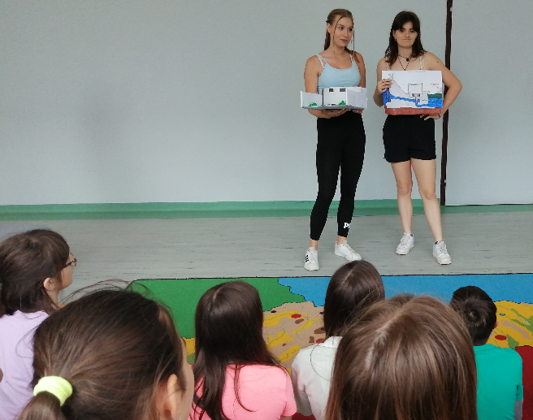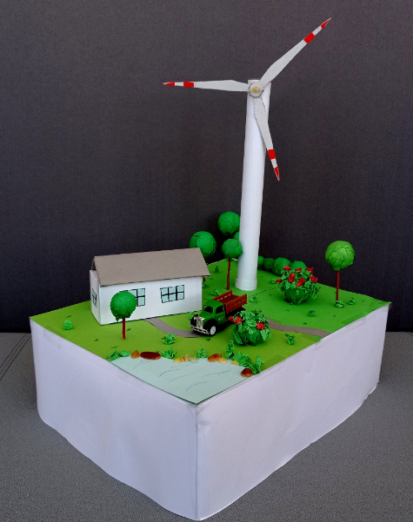

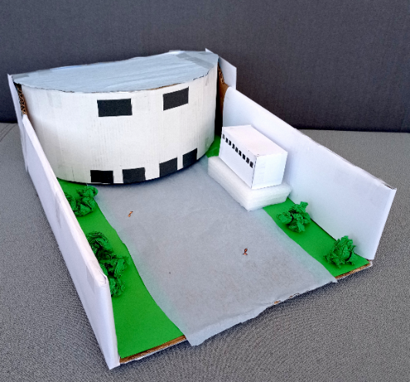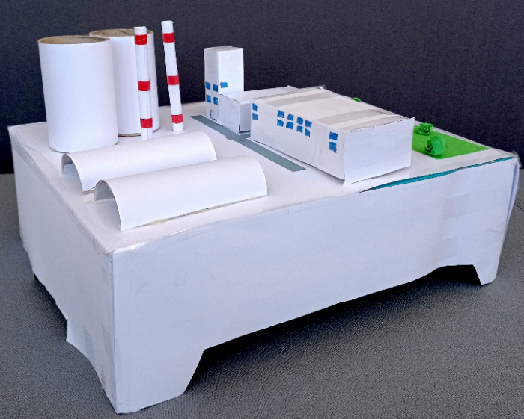

PaedDr. Katarína Chlapečková, PhD.

