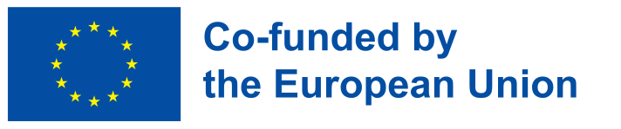 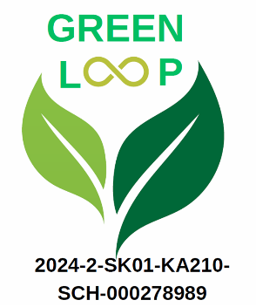

**Green Loop**

**2024-2-SK01-KA210-SCH-000278989**

**Objective:**

The objective of the project Green Loop is to integrate Circular Economy principles into school curricula to enhance sustainability education. It aims to improve students' sustainability knowledge and teachers' professional skills through innovative teaching methods, training, and collaboration. By focusing on environmental challenges, it seeks to promote active EU citizenship, develop students' critical thinking and key competencies, and enhance digital literacy for both teachers and students.

**Implementation:**

The project "Green Loop" will implement activities including teacher training workshops on integrating Circular Economy (CE) principles, the creation of a Digital Activity Book, interdisciplinary student projects, and community engagement events. Key activities include "Circular by Design," "Waste Wisdom," and "Renew, Reuse, Revitalize," focusing on sustainability education through practical workshops, collaboration, and innovative teaching methods.

**Results:**

The expected results of the "Green Loop" project include developing comprehensive teaching resources on Circular Economy (CE), enhancing digital skills among educators, increasing students' critical thinking and key competencies, and fostering community engagement through workshops and events. The project also aims for improved teacher competency in sustainability education and an increased proficiency in applying CE principles to school curricula.