Finish educational System
Finnish pedagogical approach for optimizing learning and proficiency
The expected result: high rates of proficiency and increased student motivation to solve problems.
To optimise learning in heterogeneous classes, I created Finnish-inspired learning environments, and engaged students in Three-Level Challenges. The learning environment ensures that all students become proficient in the content, while the Three-Level Challenges motivate students to improve their problem-solving skills.
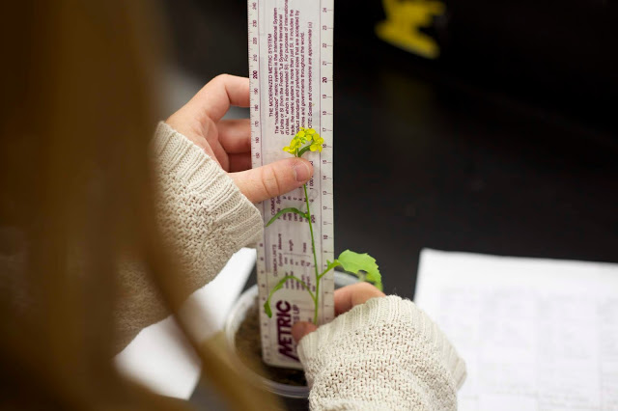
How to create a Finnish-inspired learning environment
Finnish learning units last approximately 6 to 7 weeks, and are designed to optimise learning for every child. The environment is supportive, non-competitive and collaborative, and is designed so that all students can become proficient. Teachers need to believe that all children can and will learn, they must be willing to support students as they struggle, and they need to provide the time necessary for all students to learn.
In this model, instruction is structured to develop a strong foundation of knowledge, and key concepts are frequently revisited to allow enough time for slower learners to learn the basics and for higher achievers to extend their learning. Students have to produce something almost daily to demonstrate what they’ve learned, and are given a choice of topics so that they can focus on areas that interest them.
Three-Level Challenges
Three-Level Challenges are designed for students in classes that are too large for personalised, end-of-unit assessments, or for those who are ready for competition. The challenges are divided according to proficiency – basic proficiency (Level I), applied proficiency (Level II), and advanced proficiency (Level III); and are usually given at the end of the 6-7 week unit, when students have learned the basics, are prepared for an assessment on content proficiency, and are motivated to solve more difficult problems.
Students feel more motivated when they are confident in all they have learned.
Students feel more motivated when they are confident in all they have learned. Solving their first challenge – even with a small amount of teacher guidance – propels many to continue working to achieve more difficult problems. Solving one challenge leads directly to solving the next problem, and as a result, many students strive to complete two or more challenges – even when they are only assigned one!
Students can change levels at any time, if they find the challenge too easy or too difficult, and can always come back for tutoring and try again. The goal, ultimately, is for every student to learn, become proficient in the content, and increase their ability to solve problems.
Results
According to long-term experience, students appreciate choosing the challenge that suits them best, and most succeed in solving more than one level. Some students receive lower grades than they expect, but failing is rare. I observe increased motivation, higher content knowledge, increased self-efficacy, and improved problem-solving skills in most students. Some students complain that it is too difficult to earn an “A” because they aren’t allowed to take a multiple-choice test, and one or two students may not be engaged in the process because they’re dealing with outside-of-school traumas. Students who need even greater challenges ask to try Levels IV, V and VI – and sometimes, students who solve these advanced problems are those who are typically disengaged from traditional schooling, and who often fail many of their other classes.
There are times, of course, when the Three-Level Challenges are not as successful as it would be expected; but this is likely due more to the inability to design suitable Three-Level Challenges, rather than students’ level of engagement in the process.

