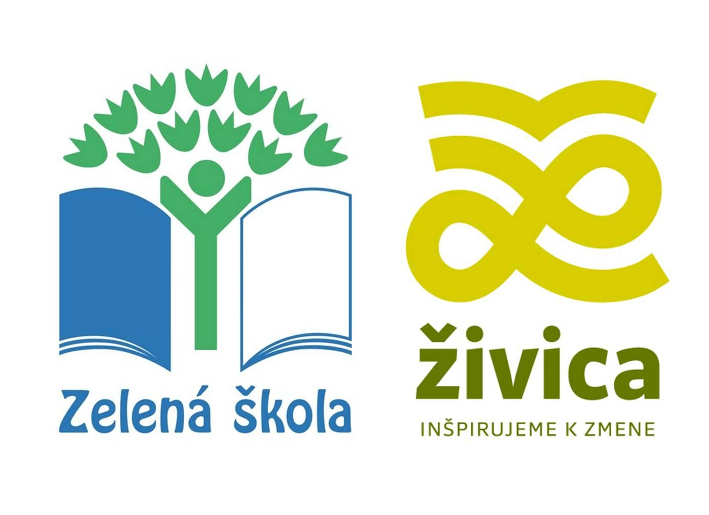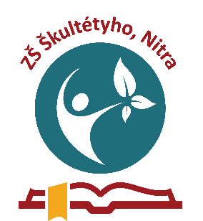
www.zelenaskola.sk

Eco- Schools

Our school Základná škola, Škultétyho 1, Nitra, SLOVAKIA has been a member of the international net of the Eco-Schools since 2014, which is one of the largest global sustainable school programme – it starts in the classroom and expands to the community by engaging the next generation in action-based learning.
Eco-Schools' primary objective is to help schools to implement a gradual programme of education for sustainable development and in so doing, help students to develop the knowledge, skills and motivation they need to address and tackle the challenges of the world around them.

In the period from 2021 to 2023 our priority topic was energy and the aim to decrease energy consumption in 4% and heat consumption in 4%.
Agenda of this period included a lot of activities:
- Peer education: energy production, renewable resources of energy, saving energies at school, home, Green energy
- Excursions: Electric Power Station in Piešťany (May 2022), Hydroelectric Power Plant in Gabčíkovo (June 2023)
- Fireflies: Checking the switching off the lights
- Information banner: real consumption of energies in euros
- Actions: a week without a lift, a day without a mobile phone, Eco-mobility week. walk to school, by bike, by scooter
- Workshops: alternative energies- kinetic toys
- Defence of the certificate Eco-School

