Excursion – Regional Waterworks Company

On 25 January 2023 the class VII.A took part in excursion in Regional Waterworks Company. The students visited laboratories, where are carried out Chemical, Physical, microbiological and hydro biological tests of drinking and utility water. The students had an opportunity to see how the different devices work and what their role is. In the workshop they saw a presentation with interesting colourful experiments and Computer analyses. They also had a chance to practice their skills necessary in research: they worked with automatic pipet, observe bacteria through special microscopes. They realised that having drinking water available all the time they can´t take for granted. It is also very important to clean waste water. Specialists regularly take samples from springs, rivers and lakes from our region and carry tests and analyses. An average time to analyse a sample is 7 days and daily they evaluate about 50 samples. The excursion was very interesting.
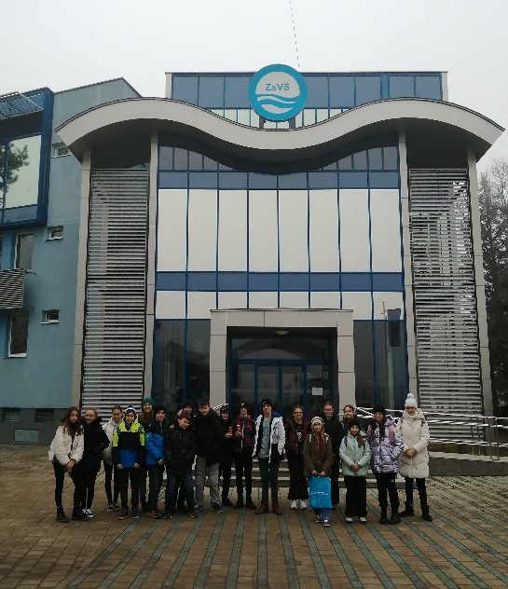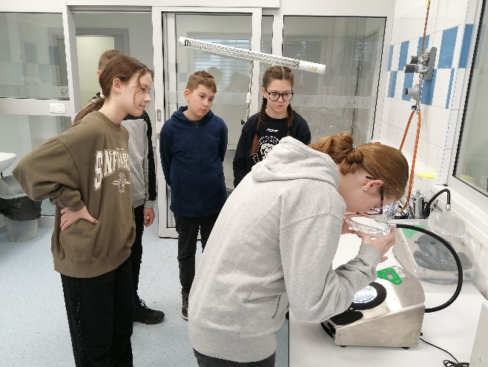

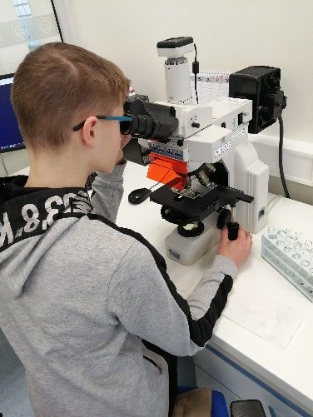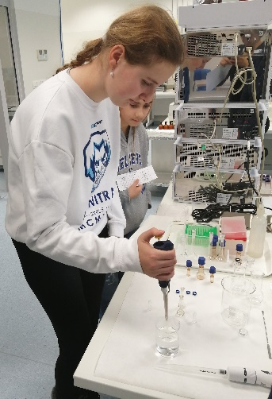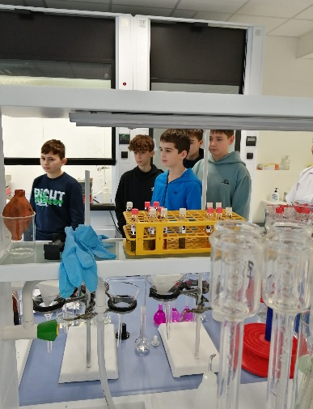

PaedDr. Katarína Chlapečková, PhD.

