**Reading for Children with Special Needs**

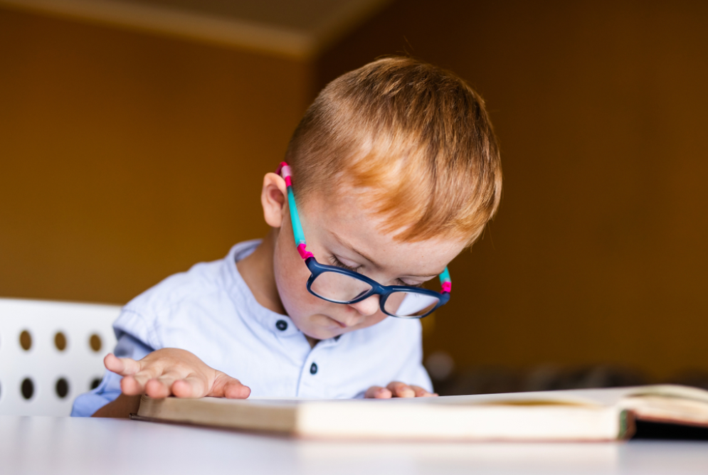

Reading is an indispensable developmental tool for all children, including those with special needs. It opens up a world of opportunities, fostering cognitive development, enhancing communication skills, and promoting emotional growth. For children with special needs, reading can serve as a bridge to understanding the world around them, offering a structured yet wonderfully flexible way to learn and explore.

Reading plays a multifaceted role in the lives of children with special needs. It promotes language and literacy skills, which are foundational for effective communication and academic success. Beyond the technical skills, reading can also become a soothing activity that improves concentration and reduces stress. For children who might struggle with verbal expression, books offer alternative ways to communicate feelings and thoughts through the recognition of emotions in characters and scenarios. Additionally, reading stories that depict social interactions and emotional experiences can enhance a child’s ability to navigate real-life situations, thereby strengthening their social skills.

Choosing the right reading material is essential to making the reading experience both enjoyable and beneficial. Books with bright, engaging illustrations and simple text can capture attention and enhance comprehension. Additionally, stories can reflect their own life experiences and challenges can make the narratives more meaningful. Consideration of the child´s individual interests, whether it´s animals, fantasy worlds, or everyday adventures, can further personalize the reading experience. Furthermore, books that incorporate sensory elements, like texture or sound, can provide a multisensory reading experience that caters to various learning preferences and needs.

It´s essential to integrate regular reading times into the child´s routine, as consistency can provide a sense of predictability and security. Creating a comfortable reading environment complete with soft lighting, cosy seating, and minimal distractions, can further enhance their focus and enjoyment. Personalised reading spaces can be tailored to the child´s sensory needs, such as noise-cancelling headphones for children who are sensitive to sound.

Various adaptive tools are available to support reading for children with special needs, each designed to address specific challenges and enhance the reading experience. Audiobooks, for instance, can be particularly beneficial for children with visual impairments or reading disorders, providing an auditory alternative that can help them keep up with their peers. E-books with adjustable font sizes and background colours can cater to those with visual or cognitive difficulties, offering customisable settings to reduce strains and increase readability. Tactile books, which include textures and physical elements that children can touch and feel, offer an engaging way to support sensory integration and fine motor skills. For children with limited mobility or severe motor impairments, eye-gaze technology and switch-accessible devices can enable them to access digital reading materials with ease. By offering these diverse tools, we can ensure reading becomes an inclusive and enjoyable activity for all children, regardless of their unique needs.