EVERYTHING YOU NEED TO KNOW ABOUT THE SWEDISH EDUCATION SYSTEM
The Swedish Education Act states that all children and young people are to have equal access to education, regardless of gender, where they live or social or economic factors, making it the, ‘education of the future’ for many people across the world. In this article, find out everything you need to know about the Swedish Education system and what sets it apart.
Many Swedish families ask us to introduce a private tutor for their child (either in the UK, or overseas) and also trust us to give advice on school and university applications. If you wish to discuss the different options for your child’s education, please contact one of our education consultants.

AN OVERVIEW OF THE SWEDISH SCHOOL SYSTEM

1. PRE-SCHOOL
Preschool (förskola) is open to children from 1 to 5 years of age. Eight out of ten children at this age spend part of their weekdays there. The Swedish tradition of preschool emphasises the importance of play in a child’s development and learning. The interests and needs of children are also key components of their education in the preschool curriculum. Gender-aware education is increasingly common in Swedish preschools. The aim is for children to have the same opportunities in life, regardless of gender.

2. KINDERGARTEN
All children are offered a place in kindergarten (förskoleklass) starting in the Autumn term of the year they turn 6 until they start compulsory schooling. Kindergarten is designed to stimulate each child’s development and learning, and provide a platform for their future schooling.

3. COMPULSORY SCHOOLING
This comprises of Elementary school (lågstadiet) for years 1–3 is followed by middle school (mellanstadiet) for years 4–6 and then junior high school (högstadiet) for years 7–9. These schools are either municipally run or publicly funded schools ‘free schools’ or there are boarding schools known as ‘private schools’, which are funded by privately paid tuition.
There is a concerted effort to streamline education, as all students at primary school level take the same limited subject groups. Critics claim it has lowered results significantly among talented students without raising them within other groups. A community where a private school offers its services must support it with the same amount of money, or vouchers, per student that it provides to public schools. The amount of financing per student is the same, and schools that receive vouchers cannot charge additional fees.

4. AFTER COMPULSORY SCHOOL
Senior high school (gymnasium) is optional and free of charge. Senior high school programs run for three years. Almost all students who finish compulsory school start senior high school. To be accepted into a national program, students must have passing grades in Swedish or Swedish as a second language, English and Maths. For senior high school, students require passing grades in nine additional subjects, for a total of twelve. For a vocational program, students must have passing grades in five additional subjects, for a total of eight. As all education is publicly funded, all students have a large selection of choices. This prevents limiting choices for those with a less fortunate background, as you find in the UK.
Right to Choose
Interestingly, Sweden have a school choice arrangements where you are able to choose any other state school or a private school at no cost to yourself. If your child doesn’t like their school, it can easily be changed. Reports from the Swedish National Agency for Education have warned that it is mostly better-educated, middle-class parents who take advantage of the right to choose schools. Children from middle-class backgrounds tend to congregate in the same few, highly popular, schools.
Independent Schools
The number of independent schools in Sweden is growing, and today school choice is seen as a right. The Swedish government supports the establishment of independent schools, which must be approved by the Schools Inspectorate and follow the national curricula and syllabuses. In 2010, roughly 10% of school operations were carried out by private players. 12% of compulsory school students and 24% of senior high school students attend independent schools. There are also a few international schools whose curricula follow those of other countries. These schools are partly funded by the Swedish government and are mainly aimed at the children of foreign nationals who are in Sweden for a limited time. The independent school system in Sweden, in which education is free and students have general access to schools with the freedom to choose among a variety of providers, has attracted interest from around the world. In Sweden, some people think it is wrong to run schools for profit, and highlight examples of poor conditions and inconsistencies as a consequence of the system. Advocates of independent schools note the many positive results found in statistical surveys. One is that parents with children who attend independent schools are more satisfied than those with children in municipal schools.
Individualised Model
These schools are deliberately different from the state school model. Kunskapsskolan’s ethos is perhaps surprising to British visitors who expect independent schools to be more traditional than their state equivalent. The Kunskapsskolan at Kista is the opposite: no uniform, very informal discipline and teaching, an open-plan layout, and an emphasis on individualised learning rather than formal classes. The students negotiate their own timetable each week and can do as few, or as many, formal classes as they wish. There is a heavy emphasis on internet-based learning and there are remarkably few books.
How does the Swedish school system rank internationally?
It’s in the top 10 for reading in international rankings and has one of the most egalitarian education systems with pupils’ chances of succeeding in school being more equal in Sweden than elsewhere. Yet, it still trails behind its Nordic neighbour, Finland, which is rated the best education system in the world.
How do Swedish schools compare with the English system?
Children start school at 6 or 7, compared with 4 or 5 in the UK. English school children sit externally marked tests throughout their schooling, whereas Swedish pupils are assessed by their own teachers. Languages are compulsory for all Swedish school children, but only for 11 to 14 year olds in England. In Sweden, there are very few fee-charging schools, though 10% are “free”, state funded but run independently. These schools are allowed to make a profit if they prove they are providing a good level of education.
Why do Swedish children do so well?
Educationalists talk about the whole system being less target-driven and more child-centred. Children start later and feel less pressured by external exams. High taxation means schools are well-funded.

Primary Education
The Swedes take the education of their children seriously as is evidenced by their success rate in international learning competitions. Home-schooling is forbidden (except in very unusual circumstances) but children may enter pre-school from as young as one year old. At age 7 they enrol at primary school for a mandatory 9 year period, where curriculum choices during the first 6 years are limited through strict governmental control.

Middle Education
The final three years at primary school equate with middle school in that some subject choice is permitted depending on the school concerned. For instance, brighter students may opt for advanced maths, and more creative ones art or music. Sciences may be available too, while practical courses such as carpentry or electronics are also sometimes offered. All pupils must, however, at least receive a smattering of all.

Secondary Education
Secondary schooling lasting 3 years is not compulsory, although it is almost universally attended. Two broad main streams are offered (social sciences and natural sciences) which are further split into focus streams so that in all a range of 18 options exists. Six of these serve as entry levels towards further academic education, while the remaining 12 are more vocationally orientated. None deprive a young person of the right to go on to university though.

Vocational Education
Vocational training in Sweden is going through a process of adopting European norms and standards, while at the same time adapting to economic realities sweeping the world. That, together with a preoccupation with foreign languages during school will introduce an era of greater mobility for talented technicians across the nation’s borders.

Tertiary Education
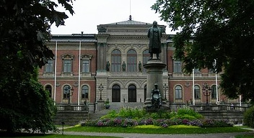Following secondary school those students who followed academic programs may apply to go to university directly, while their vocationally-minded peers may need to first complete two bridging years at college. Swedish universities offer a combination of general academic degrees, and technical degrees for example in engineering, medicine and law. This is all still free of charge for Swedish, European and Swiss consistently in international rankings and the Swedes at least rank it among Europe’s best.

Upssala University
Uppsala University is a public institution that was founded in 1477. It is located primarily in Uppsala, Sweden, a city around 45 miles north of Stockholm. In addition to facilities located in different areas of Uppsala, the university has a campus located on the Swedish island of Gotland. Some programs only available at the Gotland campus are conservation as well as game design. Students from European Union and European Economic Area countries and Switzerland do not pay tuition. But international students from outside these areas are charged tuition, which varies by academic discipline, with medical, science and technology-related studies costing more. The university does not provide housing, except to exchange students and tuition-paying master’s students. Outside housing organizations manage the residences for the school.
The university offers studies in the humanities and social sciences, medical and pharmaceutical, and science and technology disciplines. The school’s academic calendar is semester-based. The university’s medical programs are affiliated with Uppsala University Hospital, where clinical training and research take place. The primary language of instruction is Swedish for undergraduate programs, but a number of both Swedish- and English-taught master's programs are available. All of the university's international master's offerings are English-taught, including programs in computer science, entrepreneurship, and peace and conflict studies. The university has many research centres, including the Uppsala Centre for Russian and Eurasian Studies, the Centre for Natural Disaster Science and the Uppsala RNA Research Centre.

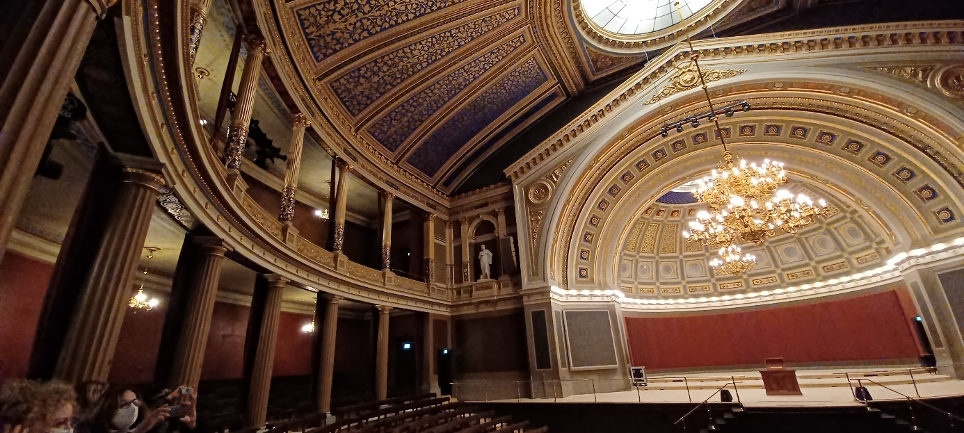

Teaching methods and tips
The world is changing faster than ever now, and new teaching methods are needed in order to prepare children and young adults for the future. One of these teaching methods is 'active learning', a research-proven method that is motivating even the most passive and shy of students to take control of their own education.
Christina Peters is a languages teacher at Sigtunaskolan Humanistiska Läroverket (SSHL), a coeducational independent boarding school set in the countryside north of Stockholm, and a confirmed proponent of ‘active learning’ .
She sometimes even uses the school’s bucolic setting as a teaching tool. “Especially in spring, I like to send the students out into the grounds with their phones to take a picture of something that inspires them. A leaf or a flower perhaps.”
When the children return to the classroom Christina sets them short exercises. “They need to talk about the object in German. Okay, what is it? Check in the dictionary for the correct word. Where did you find it? Why did you choose this to photograph? What colour is it?’ Then they will write a short text – or maybe even a poem – about the object to accompany the photo, and we’ll have a little exhibition about it so that others can see it, and maybe they can write something too in German.”
Enables shy students to engage more in lessons
Active learning is a teaching method that focuses on how the students learn, not just what they learn. The technique ensures students are actively engaged in learning and encourages more complex thought processes.
In essence, the student is almost seeing the subject they’re studying in 3D – they’re processing it as a whole rather than as a flat ‘you speak, I listen’ construct.
It has been proven that using active learning, which engages students through discussions, forums, problem solving, case studies, role plays and other interactive activities, results in improved academic performance compared to traditional lessons or lectures. Research shows that active learning stimulates more holistic thought processes and encourages shy students to engage more in lessons.
“I like to see my students arguing passionately in the classroom,” he says. “I ask them to research the advantages and disadvantages of something like the use of stem cells. Should we continue to use them or not? I give them 20 minutes and then I ask them to debate. But I generally don’t let them argue for the side they believe in – I tell them which side of the debate to argue for. So that even if they, for instance, disagree with the use of stem cells, they have to argue for the use of stem cells. It’s a wonderful way to get them to see all sides of an issue and it builds their confidence and critical thinking.”
Using personal history to inspire
Christina Peters regularly uses her own history to submerge her students in the German language but using a real-life context. “I often tell them about my own history growing up in the old East Germany,” she says. “When we discuss that, I bring in a box with objects from my past. Could be my East German ID card, for example or a report card from my teacher or even a flag. Then I ask a few students to work out what these objects are in German. Then they need to present this information, in German, to the other students. Then they will all discuss my cultural and historical background.”
Ejike believes the advantages of active learning are very obvious.
“Active learning is very child-centred because the students themselves have to participate in the process of their learning. They have to make the effort.”
You don’t see bored students in class
Furthermore, in a “traditional” class, it’s common for the same few students to always participate by asking or responding to questions. By contrast, a class that uses active learning activities provides all students in a class with the chance to think and engage with course materials and practice skills for learning and applying that knowledge. In short, active learning coaxes along shy students in a way that’s just not possible in conventional classrooms.
Shy kids rarely want to stand up in front of a class, according to Ejike. “But active learning slowly builds confidence by getting shy students to work in very small groups, so they can still fully participate in the class.”
But it’s also about engagement, says Ejike.
“With active learning you don’t see bored students in the classroom. You see the students being more mentally agile. You don’t see sleepy students or students drifting off, because they’re so much more involved in their own teaching process.”
And the benefits don’t end there, according to Ejike. “Another great thing is that you don’t have to wait until the end of the year exams to assess what the students have learned. You see it now, right now in the classroom, right in front of you. Active learning makes assessment immediate and continuous!”
Digital Education in State Schools
Free eBook - Making the journey to digital excellence
Firefly is affordable platform for parent engagement and learning continuity. It connects schools and homes every day, taking learning beyond the classroom and helping to unlock the potential of every student.

Save teachers time and frustration
A single, central hub for teachers makes it easy for them to share resources and collaborate online, track the progress of every student, Firefly supports effective learning both at home and in the classroom.

Help students close the learning gap
With all of their tools and resources in one secure space, giving them the information and clarity they require, available to them whenever they need it, Firefly helps students achieve their personal best.

Engage parents in the learning experience
Sharing the latest news and school events, alongside information about their child’s assignments, achievements and wider school experience, Firefly makes it easy for parents to be part of the learning conversation.

