Europass Teacher Academy

Art as Therapy
Art is a universal language, accessible to students and teachers of diverse backgrounds and abilities.
Collective art-making is an exercise in sharing critical thinking, problem-solving and classroom management.
Though group painting, installation, or other creative challenges, team members will practice skills, transferable to the classroom – such as effective communication, critical thinking and compromise.
In “creating” together individuals will work toward a common goal and build trust in one another, resulting in a healthier and happier school environment for teachers and students.

Art as Therapy: Self-Expression and Special Needs In Art Education
Barcelona

During the course participants explored the therapeutic power of visual arts engaging with various artistic techniques such as drawing, painting, sculpture, collage, mixed media, photography. Teachers were encouraged to express themselves in a free-of-judgement environment and learnt how to use art as a tool for the inclusion of students of various backgrounds, interests and abilities.
Participants were introduced to the main theories and practices of Psychology of the Arts, to experiment a holistic way of understanding and teaching the arts, empowering students’ creative process, lateral thinking, and wellbeing.
Art has an intrinsic healing power. It cleanses from stress, tensions, negative thoughts, and can positively influence blood pressure and breathing. During the sessions, participants were encouraged to create mandalas, intuitive drawings, and paintings and will engage with body-mind activities involving movements, music, and mindfulness meditations. The creative and soothing atmosphere facilitated self-expression, self-awareness, empathy, and collaboration with other participants.

Creart Inspired by Salvator Dalí, Joan Miró and Pablo Picasso
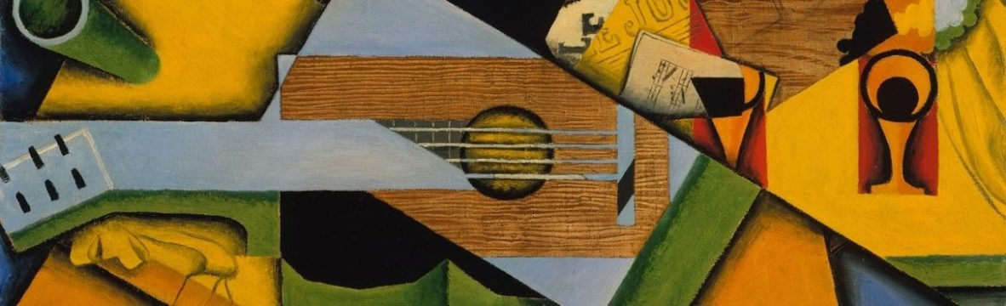
Draw, paint, and create art pieces inspired by some of the most important artists in the world! Teams were instructed on the artists’ main techniques and styles and encouraged to create artwork together with different art materials. The final product was the result of the collaboration among participants, in a space that opens up to freedom and to the exploration of many possibilities that art can inspire.

The Pattern Method inspired by Antoi Gaudí
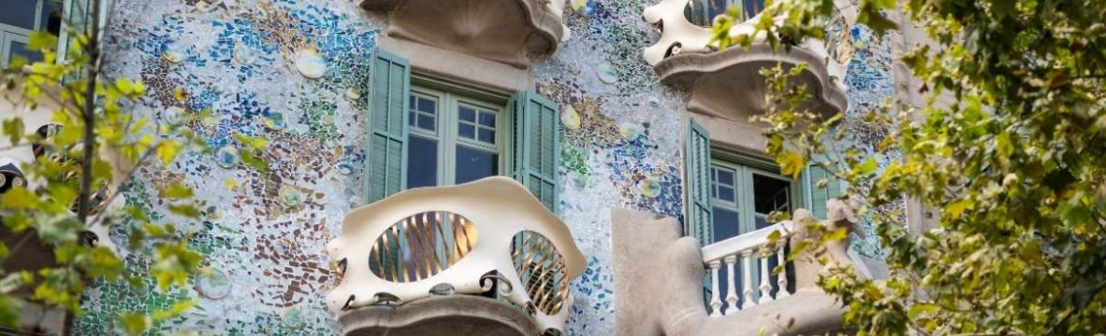

Creative team-artwork was inspired by Modernist patterns and Antoni Gaudi’s work. Each team member was invited to create a pattern that represents him/herself and then they had to create a pattern for the whole team! The final pattern could have been realised using different materials, and could have become a picture to hang, a screensaver for the company’s computers’ desktops, a card and so on.

One-fourth of the global population is at risk of developing a mental health challenge in their lifetime, and one-fifth of children and adolescents could develop mental health problems, according to a 2014 World Health Organization report. Wars, adversity, discrimination, natural disasters, and illnesses such as COVID-19 further exacerbate these unmet needs for psychosocial support.
Oscar Wilde once said, “Man is least himself when he talks in his own person. Give him a mask, and he will tell you the truth.” Art provides a way to communicate experiences when individuals lack verbal skills or when words are insufficient. Humans evolved artistic expression as an imaginative tool for adapting to changing conditions and solving problems.
Professional art therapy began in the mid-20th century as a restorative practice that allowed people to express themselves in nonverbal ways, such as drawing and painting. Trauma affects the brain’s speech centers and can limit the effectiveness of traditional talk-based therapies.

Art as a Therapy Tool
Young children typically draw and sing and dance without worrying about their abilities. That freedom and joy is often lost as they grow and begin to self-consciously evaluate the quality of their art. Too often, they become viewers of others’ art rather than being active creators, and they lose the many benefits of creative self-expression. Art teachers guide students in connecting or reconnecting with the creative practices that support mental health, and that help students to grapple with life challenges and uncertainties.
There is a connection between artistic practices and human well-being, students can best work through traumatic experiences and grapple with adversity by creative expression.
Art therapy is founded on the assumption that everyone is creative and capable of self-expression. Teachers should create a safe environment that allows students to express themselves and communicate without worrying about whether they have great visual arts skills or whether their artwork is technically brilliant. Art as therapy focuses on the process of making rather than the artistic product, which allows the students to gain insights about their situations and develop inner emotional resilience. Therapy sessions—in groups or with individuals—provide time for engaging all the senses and integrating these aesthetic experiences so that students can reimagine and rework established neural pathways to establish new ways of seeing, thinking, and experiencing.
Art teachers can channel maladaptive or dangerous instincts into creative products that allow students to communicate and work through difficult thoughts and complex emotions. They can guide a student toward taking risks in art making rather than engaging in risky behaviours in their outside life. These creative choices fulfill the brain’s desire for novelty without compromising personal safety. Rather than punch another human being, for instance, someone with aggressive tendencies could work with materials such as clay and wood that can absorb their energy and transform it into a creative product.

